**Application of AR in Education**

Daniel Kr Brahma, Jagriti Das, Khushi Rao, Jeevika Arora, Nishtha Agrawal

**ABSTRACT**

In recent years, the integration of Augmented Reality (AR) technology into various domains has catalysed innovative approaches to teaching and learning. And as we know that there remains a gap between the students' fascination of education and the traditional way of education. The project presents a novel application harnessing AR's potential to revolutionize education through the seamless projection of three-dimensional(3D) images onto real-world-objects. The project's foundation rests on integration of the Unity Engine and the Vuforia Engine, two potent tools renowned for their capabilities in creating interactive and immersive digital experiences. Through the strategic fusion of Unity and Vuforia, the developed application empowers to transcend traditional pedagogical methods, ushering in a new era of engagement and comprehension for learners. The project encapsulates the essence of an innovative educational AR application that exploits Unity's prowess in rendering immersive environments and Vuforia's advanced tracking capabilities. The resulting amalgamation redefines classroom dynamics, providing educators with an effective tool to cultivate interactive learning experiences that stimulate curiosity and critical thinking. As the boundaries of education continue to expand, the integration of AR technology and pedagogy holds the promise of shaping a more engaging and insightful learning landscape.

**1. INTRODUCTION**

A totally virtual environment is at one end of the "reality-virtuality continuum," and a genuine, physical environment is at the other. A mixed reality is in the middle of this spectrum. A mixed reality environment, which may be defined as a space where virtual and actual items coexist and interact, can therefore exist anywhere between the two extremities of the spectrum. While virtual reality is more like the virtual world, augmented reality is more like the real world. To add interactive virtual objects and information to users' perceived physical world in real time, augmented reality leverages technical computer programs.

Augmented reality can be used successfully in educational situations of many levels and subjects since it integrates the virtual with the actual world and is interactive and immersive. Additionally, it may develop inclusive learning environments that inspire students, encourage an active learning process, and provide high-quality education anytime, anywhere. On the other hand, virtual reality entails computer-generated virtual environments that perceptually surround people and imitate their physical presence within them so that they might be perceived as real. Its primary traits include the sensation of immediacy, immersion, and presence it offers, as well as the capacity to actively engage people.

Virtual reality's inherent qualities allow for the creation of secure learning environments that inspire and enthral pupils while also fostering meaningful learning. As a result, its inclusion in educational environments may produce more advantages and better learning results. As a result, the primary goal of this study is to use social media data to discover, analyse, and understand public perspectives, sentiments, attitudes, and discourses regarding the adoption and integration of augmented reality and virtual reality in education. Over 17 million tweets from January 2010 to December 2020 were recovered, specifically on the Twitter network. The time frame was selected to provide data obtained prior to the COVID-19 epidemic and to provide a more comprehensive and consistent perspective. Text mining, sentiment analysis, and topic modelling techniques were used to examine the tweets.

Our main aim is to build a method to tackle the problem and the main hope is that our study can solve this problem in near future.

**2. LITERATURE SURVEY**

An intriguing facet of AR is its potential to revolutionize the way we learn, providing learners with instantaneous access to contextually relevant information sourced from a multitude of references (2009). The foresight gleaned from the 2010 and 2011 Horizon Reports envisions a forthcoming era where AR will be ubiquitously adopted across US college campuses. In preparation for this imminent transformation, this paper furnishes a comprehensive overview of the AR landscape, delves into recent strides in AR advancements, scrutinizes the societal repercussions of AR integration, and assesses the far-reaching implications of AR on the landscape of learning and education. [1]

The use of technology in education can actively engage and motivate students, but improper implementation can lead to passive learning. Augmented Reality (AR) shows promise in addressing this issue. AR's advanced technology enables interactive experiences, bridging the gap between virtual and real-world applications. Integrating AR in education immerses students in various subjects like Medicine, Chemistry, and History. Compared to traditional methods, AR offers advantages in enhancing learning. While AR holds potential, its limitations also warrant future research. [2]

Despite a burgeoning research landscape and favourable educational outcomes linked to Augmented Reality (AR), specialists contend that the field's progress lags behind that of other digital mediums like multimedia and web services. Numerous studies are brief, one-off trials yielding differing effects. Educational AR apps are progressively reachable, even on economical smartphones, amassing millions of downloads. Yet, comprehensive, extended investigations into how AR distinctly impacts learning results compared to alternative technologies are currently lacking. [3]

The education sector is experiencing a surge in the adoption of Augmented Reality (AR), with its unique technological appeal captivating stakeholders who seek to enhance the quality of learning. However, it is worth noting that there exists a notable gap in the existing body of literature when it comes to exploring the direct application of Augmented Reality for students at the elementary education level. [4]

Medical education relies heavily on practical learning in real medical settings, where mastering complex skills to professional standards is crucial. However, due to safety, cost, and pedagogical considerations, finding alternatives for achieving clinical excellence is necessary. Augmented reality (AR), a technology that overlays virtual content onto the real world, offers a solution. By creating a realistic learning environment, AR has the potential to bridge the gap between theoretical knowledge and practical experience in medicine, enabling learners to develop and transfer complex medical skills effectively. [5]

**3. METHODOLOGY**

**3.1 Objective:**

The primary goal of this research project was to create an educational software that uses Augmented Reality (AR) technology for better learning experiences. The app's goal is to seamlessly merge virtual and real-world content, bringing static photographs to life with interactive 3D objects and insightful descriptions.

**3.2 Tool Selection:**

To meet the goal, two strong tools were chosen: Unity Engine's Asset Store and Vuforia Engine. The Asset Store in Unity Engine offers a varied choice of free 3D assets, animations, and textures, allowing for quick creation while saving significant resources and time. The Vuforia Engine was chosen as the foundation of the AR software because to its ability to construct and specify picture targets with great precision.

**3.3 Image Target Creation:**

The Vuforia Engine is used to identify images and define image targets. These image targets represented real-world items or images that served as AR app triggers. The construction of image targets was critical to ensuring precise alignment of 3D models with the designated points in the actual world.

**3.4 App Development in Unity:**

The AR app has been developed using Unity's dynamic development environment. Vuforia Engine image targets were smoothly merged with 3D models from Unity's Asset Store. The 3D models were rigorously arranged and aligned to guarantee they showed up perfectly over the picture targets when activated by human input.

**3.5 Descriptions of 3D Objects:**

To improve the educational value of the AR software, short explanations were created for each projected 3D item. These explanations offered students more context and information about the meaning and value of the virtual items in the educational setting.

**4. FLOW CHART**

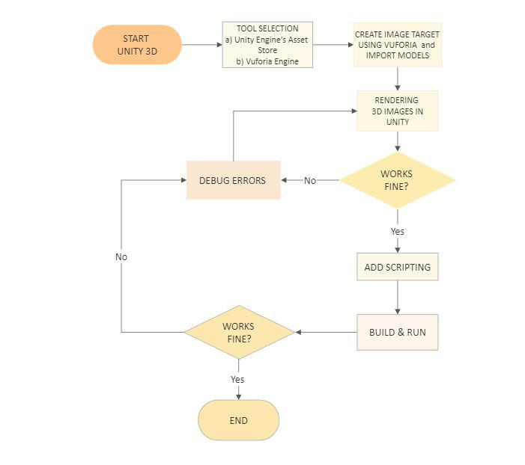

**5. RESULTS**

The outcomes of the study demonstrated the effective incorporation of augmented reality technology into the educational app, leading to a greater level of student engagement when compared to traditional techniques. The engaging and immersive quality of the application was useful in making learning more interesting and effective. These encouraging findings highlight the potential of augmented reality in reshaping education and generating dynamic learning experiences that connect with current learners.

**6. CONCLUSION**

The use of Augmented Reality (AR) technology into the educational app successfully shown its potential to revolutionise learning experiences. The dynamic and immersive quality of the app engaged learners, generating enthusiasm and curiosity in the topic. The seamless integration of virtual and real-world stuff gave a tactile depiction of complex topics, leading in increased knowledge and engagement. Using the Asset Store and Vuforia Engine in Unity Engine allows for rapid development and precise target identification. The favourable findings highlight AR's revolutionary capacity in developing dynamic learning environments that meet the requirements of modern learners. AR has the potential to turn education by making it more interactive, fun, and meaningful.

**7. FUTURE SCOPE**

It has long been acknowledged that both instructors and students' circumstances are being drastically changed by the constantly evolving nature of contemporary digital technology. In 2008, Dede notes that educators continually create new techniques of teaching and learning as our information technologies change. However, alongside these adjustments, learners' traits are always changing, as are the skill sets, areas of knowledge, and expertise that society values.[6]

According to the recent reports of Researchand Markets .com, the educational augmented reality market was valued at US$12.6 billion in 2022, and it is projected to reach a noteworthy US$1.1 trillion by 2030 by showing an impressive CAGR of 75.7% during the study period. Notably, the Higher Education category is anticipated to exhibit substantial growth by reaching US$726.6 billion with a remarkable 78.2% CAGR by the end of analysis period in 2030.[7]

The results from this study demonstrate how students' demands for hands-on, interactive learning experiences are rising. By providing immersive and interesting instructional tools, augmented reality can meet these needs. Students can better grasp difficult subjects and improve their learning experiences by using 3D models with scripted text, as advocated by "*Metadreamers*". Overall, the potential of augmented reality in education is bright, driven by the demand for more hands-on and engaging teaching strategies. It can completely transform education by giving students immersive experiences and increasing their access to and enjoyment of learning.

**8. REFERENCES**

1. Yuen, S.; Yaoyuneyong, G.;& Johnson, E. (2011). Augmented reality: An overview and five directions for AR in education. Journal of Educational Technology Development and Exchange, 4(1), 119-140.Yuen, S.; Yaoyuneyong, G.;& Johnson, E. (2011). Augmented reality: An overview and five directions for AR in education. Journal of Educational Technology Development and Exchange, 4(1), 119-140.

2. A Review of Research on Augmented Reality in Education: Advantages and Applications Nor Farhah Saidin, Noor Dayana Abd Halim & Noraffandy Yahaya; Faculty of Education, Universiti Teknologi Malaysia, Malaysia (2015).

3. Augmented Reality in Education: Current Status and Advancement of the Field Matjaž Kljun, Vladimir Geroimenko & Klen Čopič Pucihar 27 May (2020).

4. The Application of Augmented Reality in Elementary School Education by Hidayat Hidayat, Sukmawarti Sukmawarti, Suwanto Suwanto.

5. Augmented reality in Medical Education by Carolien Kamphuis, Esther Barsom, Marlies Schijven & Noor Christoph.

6. Dede, C. (Speaker). (2008). Immersive interfaces for learning: Opportunities and perils [motion picture]. (Available from The President and Fellows of Harvard College). http://cyber.law.harvard.edu/interactive/ events/luncheon/2008/12/dede

7. “AR in Education: Global Strategic Business Report” (March 2023). In *Research and Markets*